- To: To whom it may concern
- From: JiHyeon(Veronica) Moon in PLM Transducer
- CC: Park, SungSik (Kevin) H CP US - SLS, Kim, InYoung - SLS, Green, Jody, Colon, Jose
- Date: Apr 6th, 2015
- Subject: Approval for use of Protex™ Ultra Disinfectant Wipes with Siemens transducers

This memo confirms the compatibility of Protex™ Ultra Disinfectant Wipes with the Siemens probes.

- Executive Summary:
Quaternary ammonium based disinfectants, Protex™ Ultra Disinfectant Wipes and PI-Spray II, are respectively manufactured from Parker Laboratories Inc. and Pharmaceutical Innovation, Inc. Since Protex™ Ultra Disinfectant Wipes is an equivalent solution with PI-Spray II, this memo justifies that Siemens transducer approved for use with PI-Spray II can be used with Protex™ Ultra Disinfectant Wipes.
- Analysis
Protex™ Ultra Disinfectant Wipes has the same active ingredients with PI-Spray II. Each active ingredient’s concentration is higher in PI-spray II than in Protex™ Ultra Disinfectant Wipes. Please, refer to the picture 1 & 2.
With this reason, Protex™ Ultra Disinfectant Wipes will be updated on the Transducer_Disinfectnat_Compatibility Matrix without progressing an actual long-term soaking test. This memo is a justification for customers to use Protex™ Ultra Disinfectant Wipes for transducer disinfection.
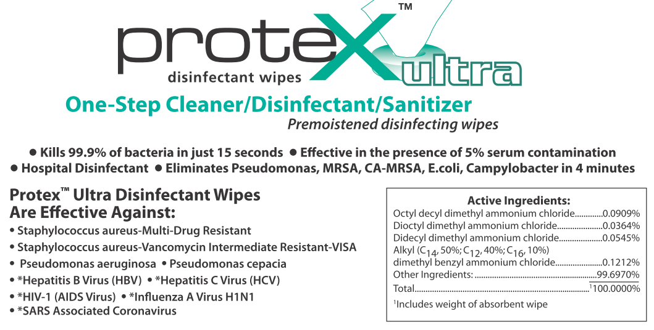
Picture 1. Chemical composition of Protex™ Ultra Disinfectant Wipes
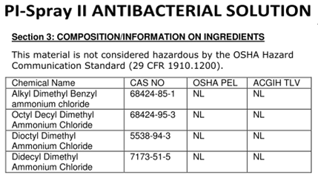
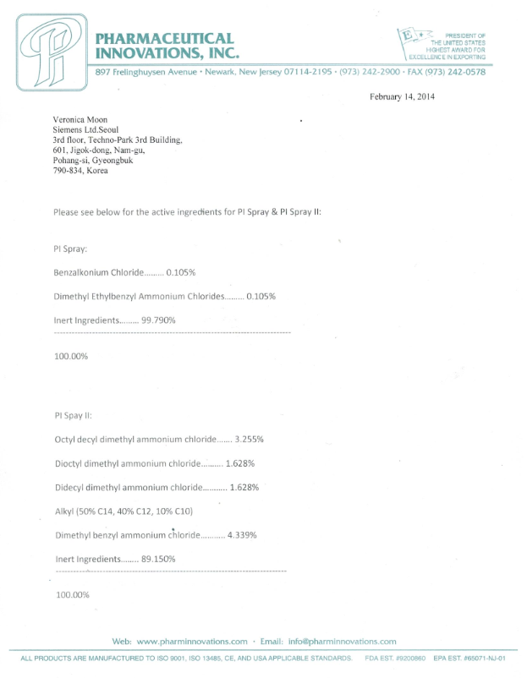
Picture 2. Chemical composition of PI-Spray II

- Conclusion
Protex™ Ultra Disinfectant Wipes manufactured from Parker Laboratories Inc is a quaternary-ammonium-based disinfectant. With this justification memo and technical information, customers are able to use Protex™ Ultra Disinfectant Wipes as a transducer disinfectant. Compatible probes, which are expected to use with Protex™ Ultra Disinfectant Wipes are the same as the validated probes with PI-spray II, checked “C” in the matrix.
For the actual update of Protex™ Ultra Disinfectant Wipes, Transdcuer_Disinfectant_Compatibility Matrix will be updated in the Siemens intranet.
https://intranet.healthcare.siemens.com/cms/USD/en/Departments/PLM/Transducer_Reliability/Pages/High-Level_Disinfectants.aspx.
- Disinfectant Compatibility Information
Table below shows compatible probes information with Protex™ Ultra Disinfectant Wipes.
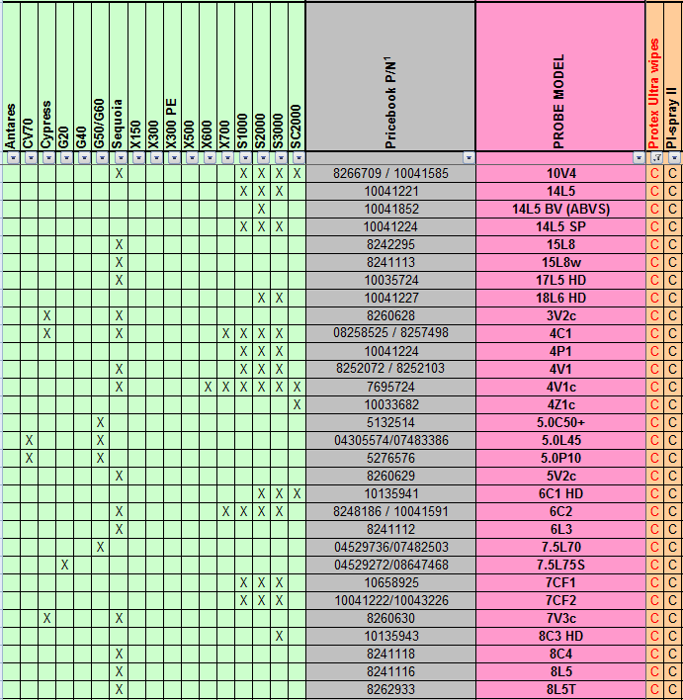
* This table does not show all the probes which are approved for use with Protex™ Ultra Wipes due to a narrow space. Please, see the actual Transdcuer_Disinfectant_Compatibility Matrix.

- Related Document
Transducer Disinfectant Qualification Protocol, P/N 5931980.
- Attachment
1) Technical Information_ Protex™ Ultra Disinfectant Wipes
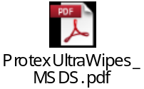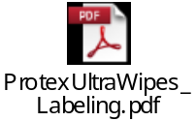
2) Technical Information_ PI-Spray II
